April 2024- Early April Newsletter
Hello Dedham Soccer Community!
We are T minus 1 week from the first games of the Spring Season!!
Shaky start to the season with the rain and the field conditions- please make sure you are checking your email for notifications from Coaches, FB, and our website for field updates.
Despite this, Dedham Youth Soccer volunteers are getting excited and amped up for the start of the season. Lining fields, putting together goals, inflating balls, a coaches meeting or two- everyone is working hard to help make our soccer program great this spring season.
Read on to find out what's going on and sign up for opportunities to help us get the season off to a great start!
In good health,
Danielle
*Trying something new- click on what catches your eye or read it all. Let me know what you think
- COACHES: Equipment needs- see below
- Preschool Kickers- 12PM slot still open!! Click here to Register, jump below for details.
- Practice/Game start dates for Town/Travel (K-HS/PG)
- Cleat/Team Shirt Swap, details below
- Opening Day Festivities- April 6th, 2024 @ Rustcraft! Info below; Share your pictures to be featured on the DYS website and our FB page!
- DYS Night @ the Revs- May 18th, 2024; 7:30PM- head below and to the DYS website for details
- MARK YOUR CALENDAR-Upcoming Events
- Check out the website and Join the DYS FB page!
- Comments, Questions? Email me
COACHES- We hope you found the coaches meeting last week valuable and supportive for the season! Couldn’t make it? Need equipment that you didn’t pick up at the coaches meeting? Have additional questions that didn’t get answered Reach out to the Travel or Town Directors

PRESCHOOL KICKERS PROGRAM: Registration still open for the 12p slot

- Practices start April 6th, 2024, at Rustcraft Field (181 Rustcraft Road, Dedham, MA 02026)
- Shirts and size 3 soccer balls are handed out to new players for the Spring Season at the first practice.
- Look for a separate introductory email from the Preschool Kicker Directors
- Read more about the program here

PRACTICE/GAME START DATES
Town (K-2 and 3/Travel (3-8) | - Most Team Practices started w/o March 25th- look for emails from coaches on times and field locations  - First Games of the Season April 6th (playing through Memorial Day weekend) look for emails from coaches on times and field locations
HS/Post-Grad | - Try-outs April 6th  - Practices Start w/o April 14th  - First game is April 21st  - Look for emails from coaches on times and field locations

CLEAT/ UNIFORM SWAP-

👟Drop off new or gently used gear (cleats, shin guards, socks, DYS uniforms) anytime to the labeled bins located at:

📥88 Abbott Rd (near DMS) or 📥116 Schiller Rd
Or bring them to any of the following “shop” sessions where you can also pick up “new to you” items at no cost!! 🛍️

There is no obligation to donate in order to pick up-take whatever you need, donate whatever you don’t!!
♻️

Shopping Session:
*Town soccer opening day!
Saturday, April 6, 9am-12pm
Rustcraft Field, Dedham

Contact Ann Stephens with any questions via text at (619)548-3604

Opening Day @Rustcraft!
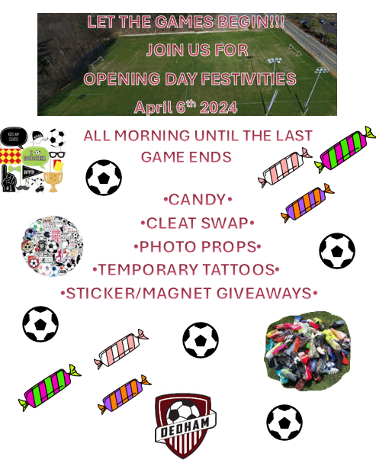
DYS Night @the REVS!!!



This spring we'll be back at Gillette Stadium to watch our New England Revolution take on Philadelphia Union for Dedham Soccer Night at the REVS. This is one of our favorite events every year, and we're thrilled to do something fun and amazing for all our teams and families.

This year we are very excited to announce that we are ONCE AGAIN partnering with the New England Revolution to give all our Dedham soccer players a FREE TICKET to attend the game!

SAVE THE DATE - - - Saturday, May 18th,2024!

New England Revolution vs. Philadelphia Union
Gillette Stadium – Kickoff 7:30 PM

As part of the partnership between Dedham Soccer and the Revs, all our players will receive a promo code via email from the Revs to attend the game! This email address: dedhamsoccerpresident@gmail.com will be used to send you the code and reminders about the game only.

We will have more details soon with instructions on how to redeem the player ticket and add-on discounted seats for the game for everyone in your family to attend.

We're looking forward to seeing you there!
If you have any questions, feel free to reach out to Kyle Lindsay from the Revolution at KyleL@Revolutionsoccer.net

CALENDAR OF EVENTS
SUNDAY | MONDAY | TUESDAY | WEDNESDAY | THURSDAY | FRIDAY | SATURDAY
3/24 | 3/25  Practices start! | 3/26 | 3/27 | 3/28 | 3/29 | 3/30
3/31 | 4/1 | 4/2 | 4/3 | 4/4 | 4/5 | 4/6  OPENING DAY!
4/7 | 4/8 | 4/9 | 4/10 | 4/11 | 4/12 | 4/13  Games are scheduled
4/14 | 4/15 | 4/16 | 4/17 | 4/18 | 4/19 | 4/20  Games are scheduled

On behalf of the DYS Board…Thank you for all your support!
DEDHAM SOCCER on …3!
You received this email because you are a member of Dedham Youth Soccer Association. If you no longer wish to receive these emails, you may click here or by logging in, clicking on Edit Family Information, and selecting the Opt-out checkbox next to your email. Please note that by unsubscribing you may miss important updates from Dedham Youth Soccer Association

